Experiment #1

VPP
- 13.5 V
- Max 60 mA

VDD
- ESP32 30-pin (3.3V)

Wiring
- Direct solder (caps and stuff soldered onto adapter)

Code
- V1

------------------------------------------------

Observations
- It works!!!
- Using back side of adapter
- Using new data cable from mom’s monitor
- Using power supply
- Works consistently even after unplugging long wires
- Video: https://photos.app.goo.gl/QmFq3MBorGkL8vKG6

Questions
- Is the problem long wires?

Conclusions
- Use this hardware setup from now on

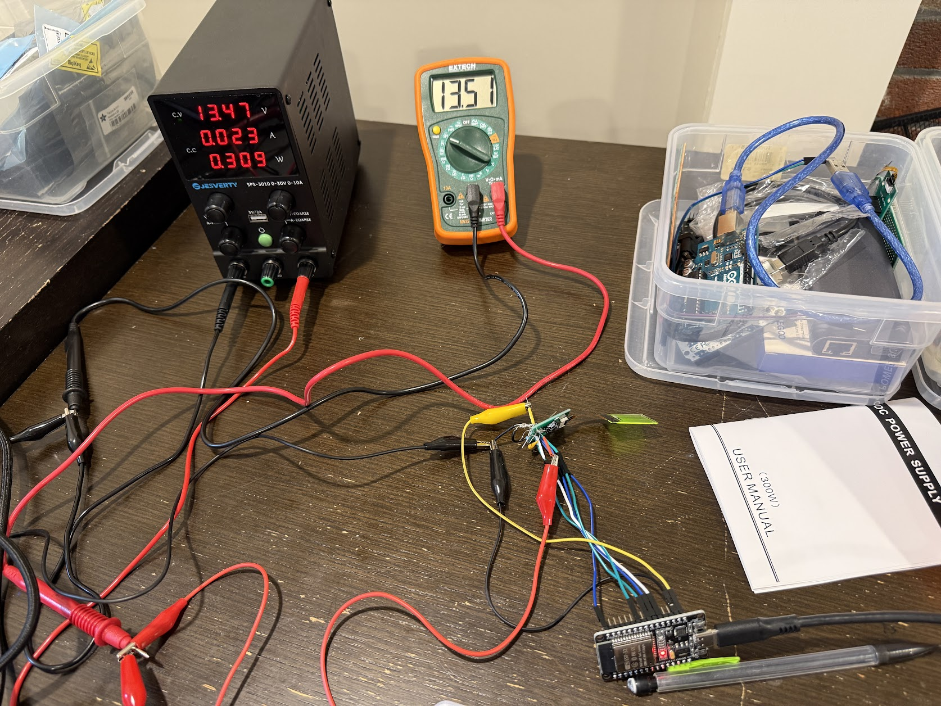
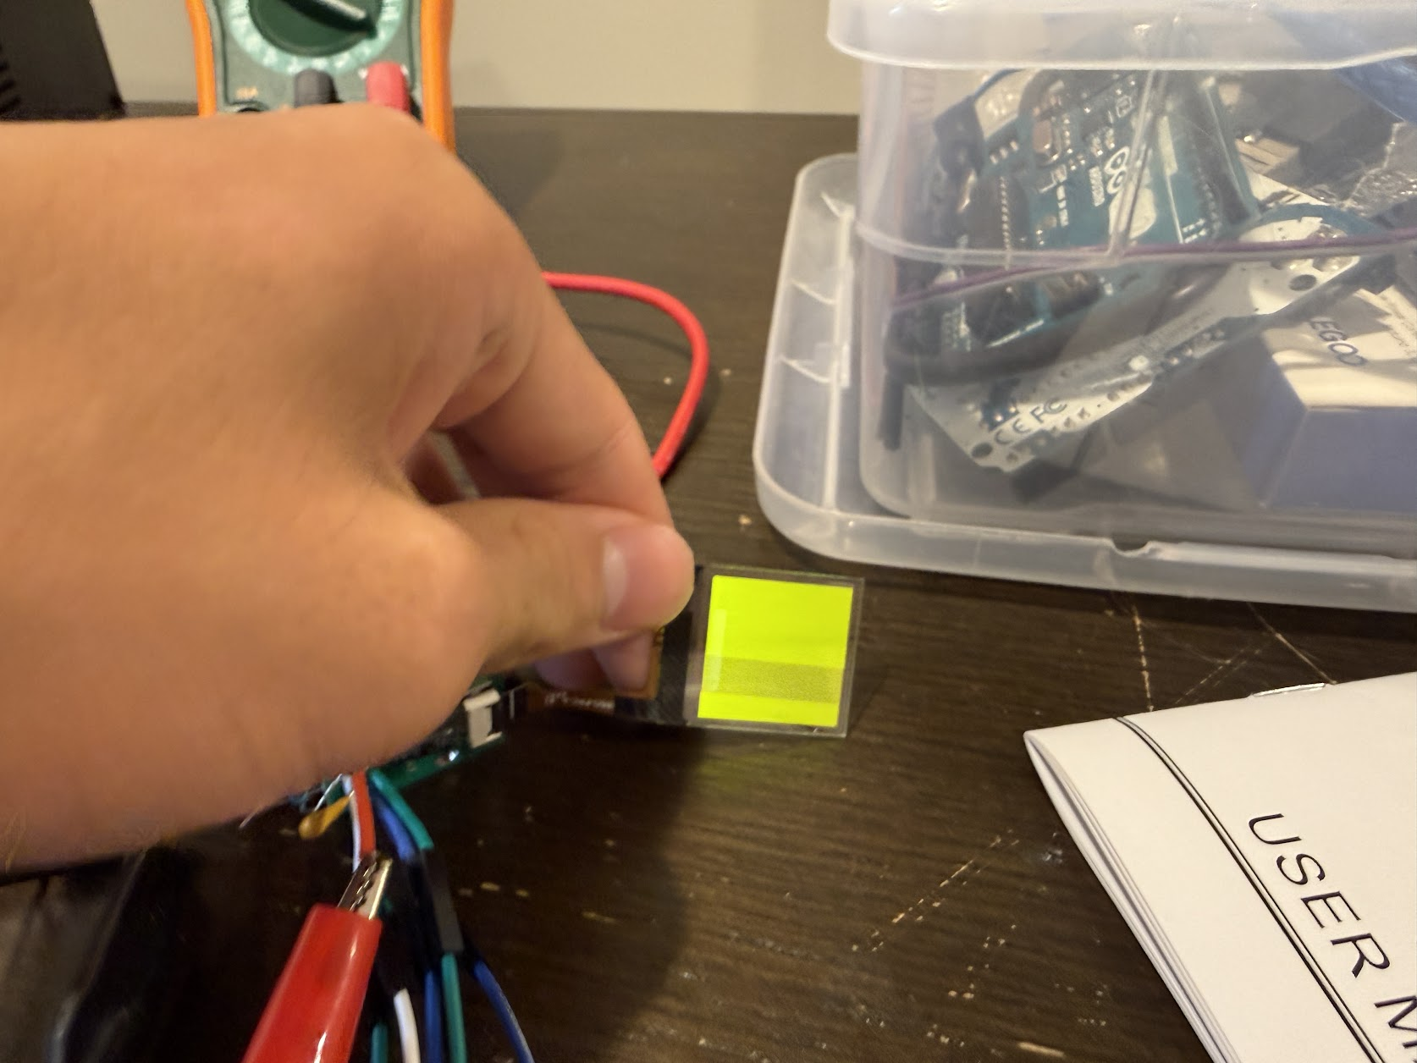

Experiment #2

VPP
- 13.5 V
- Max 60 mA

VDD
- ESP32 30-pin (3.3V)

Wiring
- Breadboard

Code
- V1

------------------------------------------------

Observations
- Doesn’t work
- VCOMH slowly climbing from 0 mV up to ~17 mV
- IREF at 0
- Using long wires, may prevent
- No power draw

Questions
- Is the problem long wires?

Conclusions

Experiment #3

VPP
- 13.5 V
- Max 60 mA

VDD
- ESP32 30-pin (3.3V)

Wiring
- Direct solder (caps and stuff soldered onto adapter)

Code
- V1 u8g2, V2

------------------------------------------------

Observations
- U8g2 works, SH110X works
- Same hardware setup as #1
- Screen is aligned
- Only a few boards work

Questions
- What’s special about these boards - factory defect OR poor wiring on my part?

Conclusions
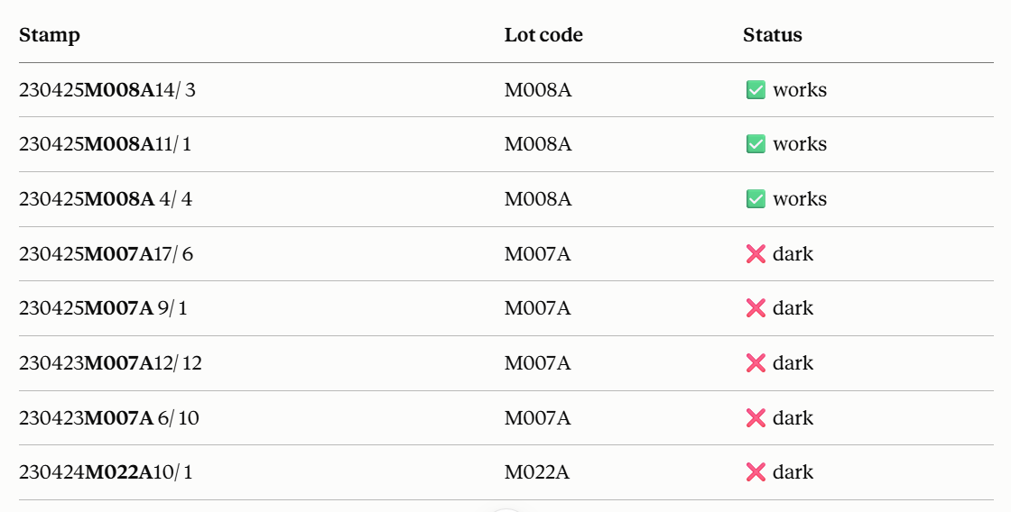
Experiment #4

VPP
- 13.5 V
- Max 60 mA

VDD
- ESP32 30-pin (3.3V)

Wiring
- Direct solder (caps and stuff soldered onto adapter)

Code
- V1 smoke test

------------------------------------------------

Observations
- Doesn’t work at first - but spotaneously, after I unclipped the DMM lead from the VCOMH and put it in series with the 3.3v pin
- Fixed - after I checked all the wiring, tested the caps and resistors (cap readings were wonky), and clipped all the external leads from the adapter so they wouldn’t short
- Tested boards
  - 11/1, 14/3 works (at first)
  - When I tested 4/4 it didn’t work AND the PSU says C.C., even with other boards - is there a short?? Where? - other boards also not working now
    - I think the VPP cap is dead - DMM can’t detect capacitance and when measuring continuity/resistance, it starts at ~150 ohms and slowly rises to ~650 ohms
    - Removed VPP cap. Continuity says VPP and GND are still shorted somehow. Fixed PSU so that now it also says C.V., but says C.C for a split second first.
    - Ok, I figured out that the problem is not with the board, but with the PSU. About 200 ohms of resistance across + and - terminals. But Gemini says it’s normal. The CV thing is also fine now.
    - Soldered on new VPP cap. Still not working.

Questions
- It has something to do with bad wiring… maybe that I accidentally shorted something?
- Something to do with the external leads I clipped?

Conclusions
- I think poor wiring is making the system fluctuate and become unreliable.
- Make PCB setup for the adapters, try from there because it’s more reliable
Experiment #5

VPP
- 13.5 V
- Max 65 mA

VDD
- ESP32 30-pin (3.3V)

Wiring
- PCB single-board

Code
- V1 smoke test

------------------------------------------------

Observations
- Doesn’t work - just like experiment #4
- Polarity, soldering is fine
- VCOMH is a few millivolts
- IREF is 0.9V when both power sources are plugged in
  - Slowly declining by a few mV when power supply turned off
  - Still about same rate of declining when logic supply turend off but jumps down to ~50 mV
- Video: https://photos.app.goo.gl/Fwa7Zs6mWH1PJWmbA

Questions
- What is the difference between the two videos?
- Why does changing around the hardware just a little make it work again or not work again?
- Is it something with the power supply or the hardware setup?

Conclusions
- PCB/wiring quality **likely** doesn’t affect it that much or at least isn’t the core problem **for now**
- Probably not a problem with code either
- Record myself all the time to catch the times where it starts or stops working
- Analyze other people’s boards
  - 1. See microamp draw on power supply to see if the board’s really not responding or just idle
  - 2. Add 10k resistor between RES/CS and 3.3V on the panel (try with the pcb board first since it’s easy because you can use top headers - if that doesn’t work test with direct solder board)
Experiment #6

VPP
- 13.5 V
- Max 65 mA

VDD
- ESP32 30-pin (3.3V)

Wiring
- Direct solder

Code
- V1 smoke test

------------------------------------------------

Observations
- Works and doesn’t - let me explain
  - Didn’t work first time, I physically shook the wires and the power supply and esp32 and the module to see if it was a wiring placement issue, but nothing happened
  - Turned off - didn’t touch anything, any wires, whatsoever, just clicked button on power supply and unplugged computer wire
  - Next time I turned on, just by plugging in computer wire and pressing button on power supply, it turned on. I shook the wires the same way and it didn’t turn off.
  - Then I turned it off and back on both VDD and VPP, and it wouldn’t turn on again
  - Tried it once more and also wouldn’t turn on again

Questions
- Is this really about the wiring? Or something more apparent?
- Why is there no pattern? And why are the times when the display turns on so much rarer?

Conclusions
- I think it’s an issue with the boot sequence, specifically with the display IC
  - Internal IC boot sequence might have quality issues where most of the time it fails to boot correctly, but sometimes correctly. Maybe a loose pad, etc.
  - If I remember correctly, the fresh modules also had this issue even though they’d never been used before. Factory issue?
- I need to follow up with company and other people who have gotten this to work and see if this is a common issue. If it is, then that will be a big hint that it’s a quality issue
  - If it is a quality issue, where else can I buy from next time? What if I need more choice like here with the transparent square form factor?
- Another unrelated - check if the PCB is correct
  - Update: it is

Experiment #7

VPP
- 13.5 V
- Max 178 mA

VDD
- ESP32 30-pin (3.3V)

Wiring
- Direct solder
- PCB single board

Code
- V1 smoke test, increased res delays and startup delay
- V3

------------------------------------------------

Observations
- Tried a few things Claude suggested after reading the prior experiments
  - Increasing the delay right at the serial.begin (from delay(1000) to delay(5000))
    - Didn’t work - also tried shaking it a bit, didn’t work
    - Tried turning the psu on right immediately after i turned on vdd, still didn’t work
  - Adding onto that, 10k’s from RES and CS to 3.3V
    - Still didn’t work, but this was only tested on the PCB
  - Adding onto that (except 10k’s only for PCB), increasing the delay after res high to 100ms and also after res low to 100ms
    - Still didn’t work
  - With 10k’s on PCB only, V3 code version
    - Still didn’t work
    - Tried turning on psu first then vdd on the direct solder, also didn’t work
- Haven’t tested VCOMH/IREF

Questions
- Do the 10k’s matter so much? Does VCOMH/IREF matter so much? Or is this just a much bigger issue with the IC?

Conclusions
- Follow up with claude
- I need to follow up with company and other people who have gotten this to work and see if this is a common issue.

Experiment #8

VPP
- 13.5 V
- Max 178 mA

VDD
- ESP32 30-pin (3.3V)

Wiring
- Direct solder (caps and stuff soldered onto adapter)
- PCB single board

Code
- V1 smoke test

------------------------------------------------

Observations (in order of experiments)
- Direct solder, part 1
  - Works - measurements are 10.48V for VCOMH, right before cap, and 10.7uA for IREF, right before resistor.
    - IREF then is 10.7V as well because of Ohm’s Law - this is different from the 0.9V in Experiment #5 (failed) - gives us good benchmarks for a working panel
  - Tried to cut IREF branch - total VPP draw goes to 10mA and panel gets dimmer immediately
  - Sometimes the panel takes a few seconds to light up - which is the RES timer I put
  - Works if I do VDD first then VPP and the other way around too
  - Tested 11 times; every single time it worked, consecutively
- PCB single-board
  - Did not work - only discernable difference was that I was measuring volts instead of microamps for IREF
  - 0.0V for VCOMH, about 0.5V for IREF, declining very slightly while everything is plugged in
  - Tested 2-3 times; all times didn’t work
- Direct solder, part 2
  - Works - everything is just like before, even after moving around the wires because I had to do the PCB test

Questions
- So is this a software or hardware problem?
  - Probably not software, or only a slight problem, because we see consistency here
  - Could be something related to my soldering/wiring, because in Experiment #4 I unclipped a DMM lead which caused it to break, and had to resolder a cap which it still didn’t work after that. Perhaps VCOMH joint got cold and resoldering it helped to make it work again.
  - Then the PCB would be explained by a defect or design flaw that is different from the direct solder, but what? The screws? Are the screw holes actually THT pads?? I don’t know…

Conclusions
- Next time can just keep circuit unbroken and use volts
- Next step: test all 8 panels
- Find out 1) what made the direct solder work and 2) how it’s different from the PCB
  - 1. What changes I made to make the direct solder work
    - Resoldered SCL pin as it fell off
      - But would this mean that the panel only works sometimes, without touching any of the wires, as it was before?
      - Could have reflowed though
    - Tightly reconnected the dupont wires connecting it to the Arduino
      - But would this mean that the panel only works sometimes, without touching any of the wires, as it was before
    - Soldered a dupont wire to VCOMH pin
      - May have reflowed a potentially cold joint or the cap connection (not the same cap as I replaced in Experiment #4)
    - IREF connected via DMM, but how would this help it?
  - 2. Differences between direct solder and PCB single board
    - Screws present on PCB but not direct solder
    - Wire/trace length - PCB shorter
    - Wire/trace width - PCB thinner
    - Wire/trace spacing
      - SI wire on PCB too close to header pins
    - Component spacing and proximity, to each other and to the pins on the adapter
    - PCB connections vs. hand-soldered connections
      - Almost counter-intuitive that hand-soldered connections work better than PCB connections
    - ESP32 pins on PCB left unconnected on one side (which it is also on direct solder) but on the PCB the grounds are connected to the plane
      - This shouldn’t be an issue though, right?
    - Adapter PCB (not the single board PCB) has holes that are silver on the inside walls, but they look like they should be for NPTH and they have no annular ring and aren’t connected to anything
      - The adapter PCB also has these two big pads on the bottom that look similar to shield pads for USBC but they don’t seem to be visibly connected to anything as far as I can see

Experiment #9

VPP
- 13.5 V
- Max 148 mA

VDD
- ESP32 30-pin (3.3V)

Wiring
- Direct solder (caps and stuff soldered onto adapter)

Code
- V1 smoke test

------------------------------------------------

Observations
- Tested the same setup as Exp. #8 but for all panels - they all work except panel 10/1. Most likely that panel 10/1 is broken (and has never turned on before) because I tested some remaining working panels after, but could suggest otherwise as well.
  - 10/1 is continuity test positive but 1 out of 8 panels is definitely more reasonable for factory faulty
  - NOTE that 10/1 is the blue panel that I tested a lot with before and may have shorted a few times. I purchased it way before, not with the other panels. This is probably why it didn’t work.
- Sometimes turned off multimeters when switching panels, mostly not.
- Detailed video of experiment and setup here

Questions
- Do we know that this setup is definitive? Is the 10/1 outlier a critical breaking point or not?
  - It makes sense to me that the panels do work, and it’s my setup’s issue
- If it is definitive, what makes it so? How can I explore the setup and what would be different from the PCB that gives us any insight?

Conclusions
- Refer to questions above
- Now we know that our setup is almost perfect, and the boards (except 10/1) have worked at least once!

Experiment #10

VPP
- 13.5 V
- Max 148 mA

VDD
- ESP32 30-pin (3.3V)

Wiring
- PCB single board

Code
- V1 smoke test

------------------------------------------------

Observations
- Soldered on row of headerpins for the other side of ESP32
  - Note that in the middle some of ESP32 pins got slightly bent because I used two rows of headerpins and they were slightly too big, so I had to force them to sit next to each other.
- Tested with 11/1, monitoring VCOMH/IREF, didn’t work
  - VCOMH 0V, IREF fluctuating around 0.77V

Questions
- Any connection with VCOMH = 0.77V * VPP?
  - No - it should be just microamp leakage amplified by 1M ohm resistor

Conclusions
- Still may have something to do with soldering.

Experiment #11

VPP
- 13.5 V
- Max 149 mA

VDD
- ESP32 30-pin (3.3V)

Wiring
- PCB single board

Code
- V1 smoke test

------------------------------------------------

Observations
- IT WORKS!!! It finally works!! For all boards (except 10/1)! I was pondering why resoldering helped my direct solder board and suspected that could have something to do with the PCB. The PCB should be perfectly connected (which I checked with a continuity test to the pins of the footprint of the adapter, but my soldering could be bad. Continuity test between PCB and adapter confirmed. Turns out that the board only routed it to the pins of the footprint but not to the pins of the adapter - i.e. not soldered or touching pins of the adapter since 2x stacked PCBs (watch out for this next time). Cut the plastic on the top and soldered the other side, continuity test between PCB and adapter succeeded. Full video here.
  - All VCOMH around 10.75V, all IREF around 10.6V (not confirmed if all, check video)
  - Had to bend the metal pins within the black plastic header around, after cutting the plastic, so that I could probe properly
- Used ESP32 that was with the direct solder (pretty sure), haven’t tested other one yet

Questions
- Is there anything I didn’t address? For the most part I have finally cracked this 9-month mystery!
  - 10k pullups could come up later, but likely not
- How can I ensure debugging like this happens faster in the future?
  - 1. Rely on your experience and don’t panic. Focus on the determinable items. If you’ve found a pattern/theme, write that down, follow it, and always have that at the back of your mind.
  - 2. AI is helpful, but it can’t solve the problem. It can only give you somewhere to keep pushing, but it may not be the right direction. Trust your critical thinking.
  - 3. Journal like this! It’s good to save notes and think better.
  - 4. Remember that the problem is usually the smallest things… don’t jump to big things like factory defect just yet.
  - 5. Be careful of where you buy things; quality over quantity.
  - 6. Focus on the tests you do, and ask yourself what the real purpose of it is, and if there are any missteps, flaws, etc. What would it tell you if the continuity test failed for example? If the answer is nothing, skip that.
  - (actionable steps:)
  - 1. Journal
  - 2. Write down patterns and directions ranked by likelihood. Write down errors, loose ends, etc. even if they are small.
  - 3. Building off that, keep a ruled-out list with the evidence beside each entry, so you don't relitigate. Your notebook nearly does this already — make it an explicit section.
  - 4. Do things that worked, like resoldering, and apply them to all similar situations.
  - 5. Have an exhaustive and a quick checklist you can go through to make sure you’re not missing anything small.
  - 6. That said, bring-up order, always the same: rails → reset → clock → comms → function. Never debug function before rails are proven at the load.
  - 7. Establish the golden reference first. You got a reliable known-good rig at Experiment #8. If that had existed at Experiment #1, most of the middle would have collapsed into a few A/B tests.
  - 8. Bisect. Halve the system each test rather than sweeping variables. You did this at the end (PCB vs direct solder) and it immediately narrowed things.
  - 9. Record rates, not adjectives. "7/11" is data; "works sometimes" isn't. You reached this yourself and it changed the investigation.
  - 10. Some industry practices: five whys ("why did resoldering help?" was the question that cracked it) and fault tree analysis (write the failure at the top, branch into every possible cause, eliminate with evidence)
  - What other actionable steps can I take? What actionable steps have engineers, electrical and other, created to help them with debugging?

Conclusions
- Also test 750k ohm for IREF (next to 1M) before jumping into the board
- Note: make sure you override u8g2's default contrast of 0x2F (47/255) — it's very dim.
- Test different adapter configurations to see if the panels can come together
- Test if 10k pullups on RES and CS do anything
- Put labelled test pad on every panel's VPP, VDD, VCOMH and IREF on multiboard
  - Make sure the PCB traces go to that specific point and not just a net
- Give 10/1 another chance (from Claude):
  - 10/1 — try once more before discarding. You noted it's a different color, and it's the only M022A. Blue emitters have a markedly higher turn-on voltage. Give it 0xA5, contrast 0xFF, VPP walked up toward 16 V (17 V abs max), in a dark room. Two minutes, and if it lights you've learned something about the batch.
  - NOTE: Tested it, walked up to 16.75V, and didn’t work still. No VCOMH/IREF recording though.
- Tomorrow:
  - 10/1 chance on PCB with changes above
    - Didn’t work, even with walking up to 16.75V
  - Solder 750k on direct solder and 10ks on everything
    - 750ks not tested b/c I don’t have them, set contrast to max in V1 (changed)
  - Test 750k vs 1M, and 10ks difference
    - 10ks still work
- Day after tomorrow:
  - Design multiboard - labelled test pads
- Day after tomorrow after tomorrow:
  - Make very basic test firmware code (u8g2 and smoke test) for multiboard - override u8g2 default contrast. Can have claude do this
  - Final check for multiboard, send it off
- Now I can definitely design the multiboard, thinking of the same problem. I can also design either a test board just for the vertical connector, or jump right into the final PCB
- Screws had nothing to do with it
- Could test other ESP32 but not worth it - will just use this one
- The entire issue was in joint connection, from the beginning. I should trust my instincts that things need to be determinable, that there’s a determinable reason when debugging. For example, I was correct that the PCB was obviously fine, and what I soldered was not cold, etc., but that I had hidden a secret unsoldered connection.
  - Continuity tests are ALWAYS helpful.
- Another thing about joint connection - don’t use breadboards for SPI/high frequency comms, things that need to be reliable, etc. They’re not very reliable. SOLDERING IS KING. If not willing to purchase PCB, at least use perfboard.
- Some things come in serendipity. I thought of the unsoldered top connections while sitting on the toilet…
- Don’t be afraid to reach out to people for help. Like Trevor, Surenoo, upiir, etc.
- Finally, be resilient and consistent. Don’t give up. It will come. Just keep on pushing, regularly, every day or every other day.

Experiment #12

VPP
- 13.5 V
- Max 311 mA

VDD
- ESP32 30-pin (3.3V)

Wiring
- PCB multi board

Code
- Multiboard test

------------------------------------------------

Observations
- Using 750k ohm iref
- Did not work (see video)
  - At first accidentally shorted b/c power supply leads happened to be touching
  - Then it showed ~1V after that, had to readjust to 13.5V (not sure if result of shorting or because knob was changed)
  - Changed to 13.5V - still doesn’t work
  - Turned PSU on and off - still doesn’t work
- Continuity between pcb and adapter is fine

Questions

Conclusions

Experiment #13

VPP
- 13.5 V
- Max 311 mA

VDD
- ESP32 30-pin (3.3V)

Wiring
- PCB multi board (with 1st panel connected)

Code
- V1 smoke test with pinouts not adjusted and adjusted (depending on trial)

------------------------------------------------

Observations
- Tested a few things:
  - Grounds connected
  - After VDD plug out and in, IREF begins at whatever it was before, slides down a little, then 5s later (the startup delay), it stabilizes around 1.23V
  - After VDD and VPP, VCOMH charges up to about 2.23V
  - VPP and VDD stable around 13.5V and 3.3V respectively
  - RES at first is 3.2V then is pulsed (low 1.26V and high 3.3V) after 5s (but is also connected directly to esp32)
  - PSU gets a bit of current draw when only VPP is plugged in and VDD is unplugged
  - CS when VDD plug out/in is around 2.5V at first until it is pulsed low (1.27V - an average?) and high (3.3V)
  - A0 at 0.9V at first, charging up, then goes to 0V
- Differences from single-board:
  - Different pinouts
  - 750k vs 1M
  - All esp32 header pins except for D5 has a header pin even if that header pin doesn’t go anywhere
  - Every protruding pin is clipped on single board
  - On single board the adapter is sitting on the pcb, on multiboard it’s under the pcb
  - Has tester breakout pins
  - Different 4.7uF cap
  - Multiboard configuration
- Covered the soldering paste stand with electrical tape

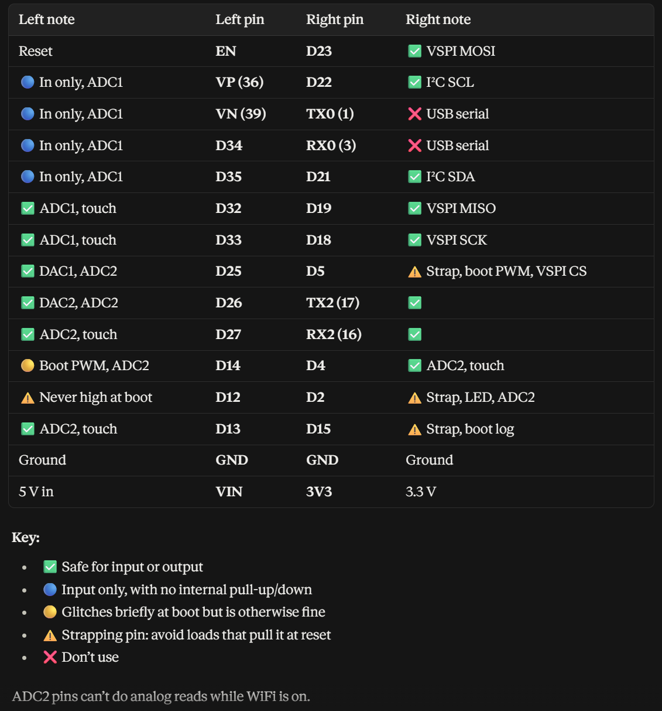

Questions
- Is the panel alive or initialized?
- Hardware or software issue?
- Does the presence of other board outputs or a bigger board affect it?

Conclusions
- We KNOW that something is happening after 5s
  - What is it?
- Next steps
  - 2. Could do continuity tests on all of the header pins on the adapter
    - Tried, everything was fine but a few which didn’t beep all the time, suspecting electrostatic discharge because when it does beep it shows 0 ohms basically
  - 3. Could sweep VPP and see if IREF and VCOMH voltage changes
    - Nope, IREF and VCOMH don’t change
  - 1. Cut the backing leads
    - Tried, didn’t work
  - 4. Try with 1Mohm
    - Didn’t work, IREF hovers around 0.59V
  - 5. Try with esp32 just connected to that portion of the multiboard
    - Doesn’t work, note that VDD and VPP didn’t have caps b/c of direct connection (and no 10k ohm pullups)
    - Tested single board w/o pullups, still works, used same esp32 and same sketch with same pinouts for the direct connection, all that’s different is the VPP/VDD caps, IREF/VCOMH multiboard layout, ground pour size
  - Additional Notes:
    - Single board still works with original V1 smoke test and multiboard-file V1 smoke test (pin numbers adjusted)
- Watched some electronic debugging videos - notes
  - Next steps: take a new board and solder the components BUT test that everything works as expected incrementally, after each component section, instead of soldering it all at once. If it doesn’t work, write down a theory and test it.

Experiment #14

VPP
- 13.5 V
- Max 311 mA

VDD
- ESP32 30-pin (3.3V)

Wiring
- PCB multi board (bare board except for one adapter with new soldering)

Code
- V1 smoke test with adjusted pinouts

------------------------------------------------

Observations
- Used the CS_3 slot
- Worked!
- I tested everything after every step, which worked
- VCOMH - 10.58V
- IREF - 10.73V

Questions

Conclusions

Experiment #15

VPP
- 13.5 V
- Max 311 mA

VDD
- ESP32 30-pin (3.3V)

Wiring
- PCB final board

Code
- V1 smoke test with adjusted pinouts, final firmware

------------------------------------------------

Observations
- Wanted to build the board like this:
  - 1. usbc with its components, test output at esp32 pad and boost converter pad
  - 2. test isolated esp32 with 5v to vin
  - 3. boost converter, test output
  - 4. module components without adapter, test pads on module adapter
  - 5. module adapter and esp32 pins, test esp32 pins, test one board
  - then
  - 1. solder everything without IO, test with firmware
  - 2. IO, test total
- Change of plans because of reflowing times:
  - 1. Everything smd at once, test output at esp32 pad and boost converter pad
    - Procedure
    - **Note: for the usbc connector, I should syringe some solder paste into the tht holes before placement
    - Note: pins 3/4, pins 6/7/8 are bridged on the board, but only 3 is connected to something so it should be ok
    - 5V on boost input is as expected
  - 2. Test isolated esp32 with 5v to vin
    - Works
  - 3. Then calibrate boost converter, solder the boost converter, test output of that
    - Calibrated to 13.55V (DMM reading, input 4.98V regulated psu)
    - Output works
  - 4. Then test the module components at their pins and at the adapter module’s pins
    - Good
  - 5. Then solder esp32 pins
  - 5. Then test the entire board
    - Works! See video
  - Then
  - 1. solder everything without IO, test with firmware
    - SOLDER WITH 750K (if can test on multiboard first)
    - Ended up using 1M
  - 2. IO, test total

Questions

Conclusions

// Surenoo SOG128128A_P112 1.12" transparent OLED (SH1107G, 4-wire SPI, external VPP)
// ESP32 DevKit V1 (30-pin) + u8g2
//
// Proven-working constructor for this exact panel (upir / sjm4306 project):
// U8G2_SH1107_PIMORONI_128X128_x_4W_HW_SPI
//
// ---------------- WIRING (single-panel bring-up) ----------------
// Panel FPC pin -> signal -> ESP32
// 1 VSS -> GND (common with VPP supply ground AND USB ground!)
// 2 SI -> GPIO23 (VSPI MOSI)
// 3 SCL -> GPIO18 (VSPI SCK)
// 4 A0/DC -> GPIO16 (RX2) (any GPIO; can be SHARED by all 8 panels later)
// 5 RES -> GPIO4 (MUST be a GPIO - do NOT tie to ESP32 EN pin)
// 6 CS -> GPIO17 (TX2) (unique per panel)
// 7 IREF -> 1M 1% resistor to GND
// 8 VDD -> 3.3V (ESP32 3V3), 1uF ceramic to GND at the pin
// 9 VSS -> GND
// 10 VCOMH -> 4.7uF (>=25V) to GND (cap only, nothing else)
// 11 VPP -> +13.5V REGULATED (7..16.5V operating, 17V ABS MAX),
// 4.7uF (>=25V) to GND at the pin
// 12 VSS -> GND
//
// Power-up order (datasheet p.15): VDD+VPP on while RES held low >=10us,
// then RES high, init, 0xAF. u8g2 handles this if RES is on a GPIO.
// Power-down: display off / VPP off first, then VDD (~100ms later).
// -----------------------------------------------------------------

#include <U8g2lib.h>
#include <SPI.h>

#define PIN_CS 17
#define PIN_DC 16
#define PIN_RST 4

// // Full framebuffer (2KB) - fine on ESP32
// U8G2_SH1107_PIMORONI_128X128_F_4W_HW_SPI u8g2(U8G2_R0, PIN_CS, PIN_DC, PIN_RST);

// void setup() {
// Serial.begin(115200);

// Serial.println("Pre-delay boot");
// delay(1000);
// Serial.println("Post-delay boot");

// u8g2.begin(); // resets panel, sends SH1107 init, display on

// // Belt-and-braces for a bare panel with EXTERNAL VPP:
// // DC-DC Control Mode Set (0xAD) + 0x8A = internal DC-DC OFF.
// // (POR default 0x8B = DC-DC on; panel has no AVDD bonded out, and the
// // upir board works without this, but external-VPP mode is the spec'd config.)
// u8g2.sendF("ca", 0xAD, 0x8A);

// u8g2.setContrast(0xA2); // datasheet "normal mode" contrast setting

// u8g2.clearBuffer();
// u8g2.setFont(u8g2_font_ncenB14_tr);
// u8g2.drawStr(10, 40, "Hello");
// u8g2.drawStr(10, 70, "Jayden!");
// u8g2.drawFrame(0, 0, 128, 128); // border = quick check of size/offset
// u8g2.sendBuffer();

// Serial.println("Init done - panel should be lit.");
// }

// void loop() {
// // blink a pixel so you can tell the loop is alive
// static bool on = false;
// on = !on;
// u8g2.setDrawColor(on ? 1 : 0);
// u8g2.drawBox(60, 100, 8, 8);
// u8g2.sendBuffer();
// delay(500);
// }

void setup() {
Serial.begin(115200);

Serial.println("Pre-delay boot");
delay(5000);
Serial.println("Post-delay boot");

smoke_test();
}

void loop() {

}

/* ---------------- MINIMAL HARDWARE SMOKE TEST ----------------
If u8g2 shows nothing, replace setup()/loop() with this. It only
pulses RES and sends DISPLAY ON (0xAF). With VDD+VPP present and a
good FPC connection, the panel MUST show random pixels/speckle
(RAM is uninitialized). If it stays fully dark, the problem is
hardware: FPC orientation/pin order, VPP, RES, or ground.
*/

void smoke_test() {
pinMode(PIN_CS, OUTPUT); pinMode(PIN_DC, OUTPUT); pinMode(PIN_RST, OUTPUT);
SPI.begin(18, -1, 23, PIN_CS);
digitalWrite(PIN_RST, LOW); delay(100); // reset pulse
digitalWrite(PIN_RST, HIGH); delay(100);
SPI.beginTransaction(SPISettings(1000000, MSBFIRST, SPI_MODE0));
digitalWrite(PIN_DC, LOW); // command mode
digitalWrite(PIN_CS, LOW);
SPI.transfer(0xAD); SPI.transfer(0x8A); // DC-DC off (external VPP)
SPI.transfer(0x81); SPI.transfer(0xFF); // Set Contrast Control command to max
SPI.transfer(0xA5); // entire display ON (all pixels)
SPI.transfer(0xAF); // display on
digitalWrite(PIN_CS, HIGH);
SPI.endTransaction();
// 0xA5 forces ALL pixels on regardless of RAM -> whole panel glows.
}

#include <Adafruit_GFX.h>
#include <Adafruit_SH110X.h>
#include <SPI.h>

#define SCREEN_WIDTH 128
#define SCREEN_HEIGHT 128

// ESP32
#define OLED_MOSI 23
#define OLED_CLK 18
#define OLED_DC 16
#define OLED_CS 17
#define OLED_RST 4

Adafruit_SH1107 display(SCREEN_WIDTH, SCREEN_HEIGHT, &SPI, OLED_DC, OLED_RST, OLED_CS, 2000000UL);

void setup() {
Serial.begin(115200);

// SPI.begin(OLED_CLK, -1, OLED_MOSI, OLED_CS);
SPI.begin();
// SPI.setFrequency(100000); // 100 kHz
SPI.setDataMode(SPI_MODE0);
SPI.setBitOrder(MSBFIRST);

delay(2000);

display.begin(0, true); // 0x3D because it's not a 128x32 display
display.clearDisplay();
display.setRotation(0);
}

void loop() {
// Re-draw your content
display.clearDisplay();

display.drawRect(10, 10, 50, 30, SH110X_WHITE);
display.fillCircle(90, 30, 15, SH110X_WHITE);

display.setTextSize(1);
display.setTextColor(SH110X_WHITE);
display.setCursor(10, 60);
display.println("Hello OLED!");

// Send buffer to screen again
display.display();

// Optional delay — adjust this to control SPI frequency
delay(200); // refresh twice per second
}

// V3 - RESET TIMING / BOOT-RACE TEST
// Surenoo SOG128128A (SH1107), ESP32 DevKit V1, external VPP
//
// WHY THIS EXISTS (Experiment #6):
// Shaking the wires changed nothing in either state, but the on/off
// state was latched at power-on. That is an init/reset race, not a
// loose connection.
//
// The V1 smoke test used a 100us reset pulse + 10ms settle.
// Both known-working implementations use FAR longer:
// u8g2 : 100 ms reset pulse, 100 ms post-reset wait
// (source comment: "far east OLEDs need much longer setup time")
// boriz : 50 ms low, 100 ms after release
// V1 was ~500x shorter than either. That is the prime suspect.
//
// WHAT THIS SKETCH DOES:
// Re-runs reset + init + 0xA5 (all pixels on) every 3 seconds, forever,
// WITHOUT a power cycle, and prints an attempt counter.
//
// This is the discriminator you need:
// - Panel sometimes lights on a re-init -> RESET/INIT timing problem.
// Fixable in software. Note the success rate.
// - Never lights on re-init, but sometimes lights after a power cycle
// -> POWER SEQUENCING problem (VDD vs VPP order/timing), not reset.
// - Lights every single time now -> V1's short reset pulse was the bug.
//
// WIRING: unchanged from V1 (CS=17, DC=16, RST=4, SCK=18, MOSI=23)
// *** VERIFY CS/A0 ON THE PHYSICAL BOARD ***
// boriz's project (and your June 30 email) use CS=16, A0=17 - SWAPPED
// relative to this. A swap is invisible to a commands-only test like
// this one, because CS and DC are both driven LOW together, but it
// breaks u8g2 and SH110X data writes.
//
// ALSO DO IN HARDWARE (still outstanding from Experiment #5):
// 10k from RES to 3.3V, 10k from CS to 3.3V.
// Until those exist, RES floats for the ~300ms the ESP32 takes to boot,
// which is its own source of boot-to-boot randomness.

#include <SPI.h>

#define PIN_CS 17
#define PIN_DC 16
#define PIN_RST 4
#define PIN_SCK 18
#define PIN_MOSI 23

// Timing - matched to u8g2 / boriz, NOT to the datasheet minimum.
// Datasheet min is 10us; real panels want milliseconds.
#define RESET_LOW_MS 100
#define RESET_SETTLE_MS 100
#define POST_ON_MS 100 // datasheet p.15: wait 100ms after 0xAF

uint32_t attempt = 0;

void cmd(uint8_t c) {
digitalWrite(PIN_DC, LOW);
digitalWrite(PIN_CS, LOW);
SPI.transfer(c);
digitalWrite(PIN_CS, HIGH);
}

void hardReset() {
digitalWrite(PIN_RST, HIGH); delay(10);
digitalWrite(PIN_RST, LOW); delay(RESET_LOW_MS);
digitalWrite(PIN_RST, HIGH); delay(RESET_SETTLE_MS);
}

void initPanel() {
SPI.beginTransaction(SPISettings(1000000, MSBFIRST, SPI_MODE0));

cmd(0xAE); // display off
cmd(0x20); // page addressing mode
cmd(0xA8); cmd(0x7F); // multiplex ratio = 128
cmd(0xA1); // segment remap (boriz values)
cmd(0xC8); // COM scan dir (boriz values)
cmd(0xAD); cmd(0x8A); // DC-DC OFF - external VPP
cmd(0xD5); cmd(0x50); // clock divide
cmd(0xD9); cmd(0x25); // pre-charge (boriz: 0x25, u8g2: 0x22)
cmd(0xDB); cmd(0x30); // VCOMH deselect (boriz: 0x30, u8g2: 0x35)
cmd(0x81); cmd(0xFF); // contrast MAX - u8g2 defaults to 0x2F which is
// very dim on an already-dim transparent panel
cmd(0xA6); // normal (not inverted)
cmd(0xA5); // ENTIRE DISPLAY ON - ignores RAM entirely
cmd(0xAF); // display on

SPI.endTransaction();
delay(POST_ON_MS);
}

void setup() {
Serial.begin(115200);
delay(5000); // let both rails settle before touching anything
Serial.println("\n=== V3 reset-timing test ===");
Serial.println("0xA5 = all pixels on. Panel should be FULLY LIT on success.");
Serial.printf("Reset: %dms low, %dms settle\n", RESET_LOW_MS, RESET_SETTLE_MS);

pinMode(PIN_CS, OUTPUT); digitalWrite(PIN_CS, HIGH);
pinMode(PIN_DC, OUTPUT); digitalWrite(PIN_DC, LOW);
pinMode(PIN_RST, OUTPUT); digitalWrite(PIN_RST, HIGH);

SPI.begin(PIN_SCK, -1, PIN_MOSI, PIN_CS);
}

void loop() {
attempt++;
Serial.printf("\n--- attempt %lu ---\n", attempt);
Serial.println(" reset + init + 0xA5 ...");

hardReset();
initPanel();

Serial.println(" done. LIT or DARK? (log it)");
Serial.println(" If DARK: measure IREF (~0.9-1.2V = chip alive)");
Serial.println(" and VCOMH (~0.77*VPP = display actually on)");

delay(3000);
}

/* ------------------- HOW TO RUN THIS -------------------

1. Power up in the DATASHEET order and write it down every time:
VPP on first (or simultaneously), THEN plug in USB.
Your notebook never records which rail came up first, and with two
independently switched supplies that order has been random. The
datasheet wants VDD and VPP both up with RES held low, then RES
released - which is only guaranteed if VPP is already present when
the ESP32 finishes booting.

2. Watch 20 consecutive attempts. Tally lit vs dark.
Write the success rate in the notebook. A rate is data; "sometimes"
is not.

3. Then power-cycle and repeat, so you have two rates to compare:
re-init success rate vs power-cycle success rate

re-init works sometimes -> reset/init timing. Software fix.
re-init never, power-cycle yes -> power sequencing between VDD/VPP.
both ~100% now -> V1's 100us reset pulse was the bug.

4. IMPORTANT: re-test the panels you previously wrote off as dead.
If the per-attempt success rate is ~20%, then five consecutive
failures happens 33% of the time by chance alone. Your earlier
dead/alive classification was taken over only a handful of tries,
so some "dead" panels are probably fine.
--------------------------------------------------------- */

I’d like to acknowledge myself, Mr. Shumway, ChatGPT, Gemini, my parents, my family, Mihika and Matteo, everyone who knows about HOLOCUBE, Claude, Professor Toor, Molly McLaughlin, Trevor Smith, upiir, VideoOverUART, Surenoo and their support team, Potter Hao, and everyone else who has positively impacted my progress directly or indirectly.
SMD Soldering Checklist and Procedure
Phase 1: Preparation & Setup
- Clean your workspace: Wipe down your desk. Dust and stray hairs will ruin wet solder paste.
- Gather your tools: Set up your hotplate, PCB, stencil, solder paste syringe, squeegee (or a plastic credit card), tweezers, and rubbing alcohol (IPA).
- Inspect the PCBs: Ensure the bare boards are completely dry and free of fingerprints. Wipe pads gently with IPA if needed.
- Organize your components: Arrange your components in the order you plan to place them. Open the packaging only right before you begin.
- Preheat check: Ensure your hotplate is on a flat, stable surface away from flammable materials and drafts.
Phase 2: Stencil Alignment & Paste Application
- Anchor the PCB: Tape down scrap PCBs or thick cardboard around your target board to create a flush, level pocket so it won't slide.
- Align the stencil: Lay the stencil over the PCB. Look directly from above and perfectly match the stencil holes (apertures) to the shiny copper pads.
- Tape the hinge: Secure one side of the stencil to your workspace with heavy tape to create a "book hinge" that flips open cleanly.
- Apply a paste line: Squeeze a thick, even bead of solder paste from your syringe across the top of the stencil holes (not directly on them).
- The Squeegee Sweep: Hold the card at a 45-degree angle. Drag the paste downward across the stencil in one smooth, firm stroke to pack the holes completely.
- The Reveal: Carefully lift the stencil straight up using your tape hinge. Inspect the board: the paste should look like sharp, distinct grey bricks. If it smeared, wipe it clean with IPA and start Phase 2 over.
- **Note: for the usbc connector, I should syringe some solder paste into the tht holes before placement
Phase 3: Component Placement (The "Golden Window")
- Set a timer: Solder paste stays optimally tacky for about 2 to 4 hours after printing. Try to finish placement within this window.
- Place large/complex parts first: Use tweezers to place microcontrollers, ICs, and fine-pitch components. Align them perfectly with the underlying pads.
- Place small parts last: Drop in your resistors, capacitors, and LEDs.
- Don't panic if alignment isn't perfect: If a resistor is slightly crooked, leave it. Surface tension will naturally pull it into alignment during reflow as long as it touches the paste.
- Verify polarity: Double-check that diodes, LEDs, and integrated circuits are facing the correct direction before heating.
Phase 4: Hotplate Reflow
- Gently transfer the board: Use tweezers or a spatula to carefully lift the fully populated PCB and set it flat onto the cold hotplate. Do not jostle it.
- Phase A - Preheat & Soak: Turn the hotplate on and set it to ~100°C–120°C. Let it sit for 1 to 2 minutes to cook off solvents and activate the flux.
- Phase B - The Ramp: Crank the temperature setting up to your solder's specific melting point peak (around 150°C–160°C for Low-Temp Bismuth, or ~230°C for standard lead-free SAC305).
- Phase C - The Liquidus Watch: Watch closely. The dull grey paste will suddenly turn into bright, shiny, liquid silver.
- Phase D - Complete the Reflow: Once all joints on the board turn shiny, wait 20 to 30 seconds to ensure total melting, then turn off the hotplate immediately.
Phase 5: Cooling & Post-Inspection
- Do not touch: Leave the board sitting entirely undisturbed on the hotplate for at least 3 to 5 minutes until the solder completely re-solidifies.
- Safe transfer: Once solid but still warm, carefully slide or lift the PCB off the hotplate onto a heat-resistant surface to finish cooling.
- Inspect under magnification: Check for bridges (solder touching between pins) or tombstoning (resistors standing straight up on one end).

